Task 2

1. Chat GPT

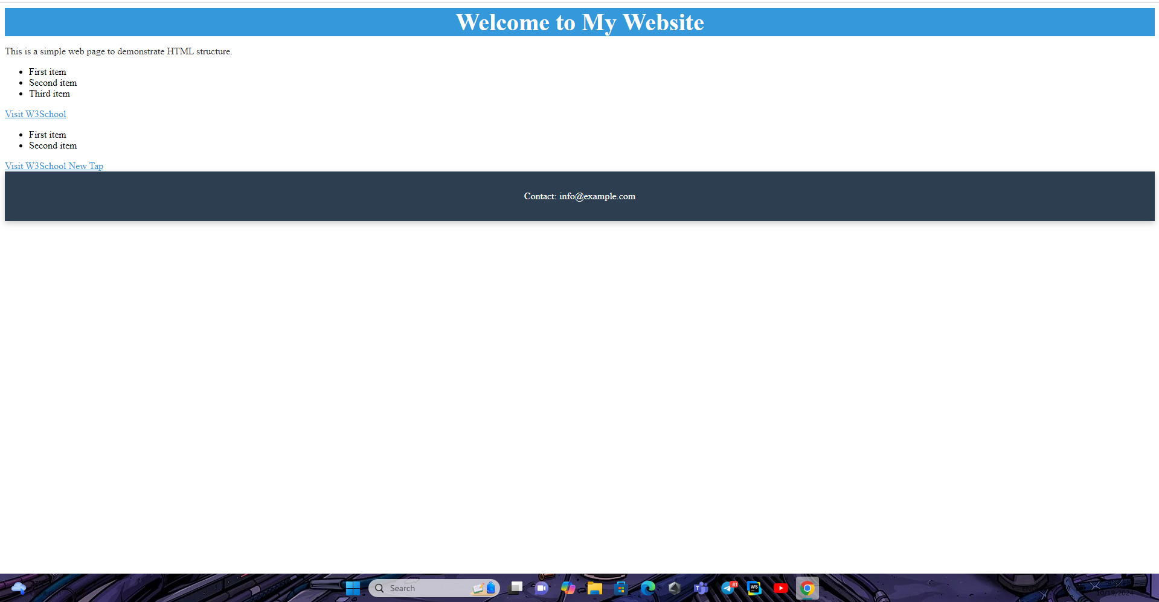

2. Gemini doesn’t match the HTML that send to do